1.Average Rating , Count by Category

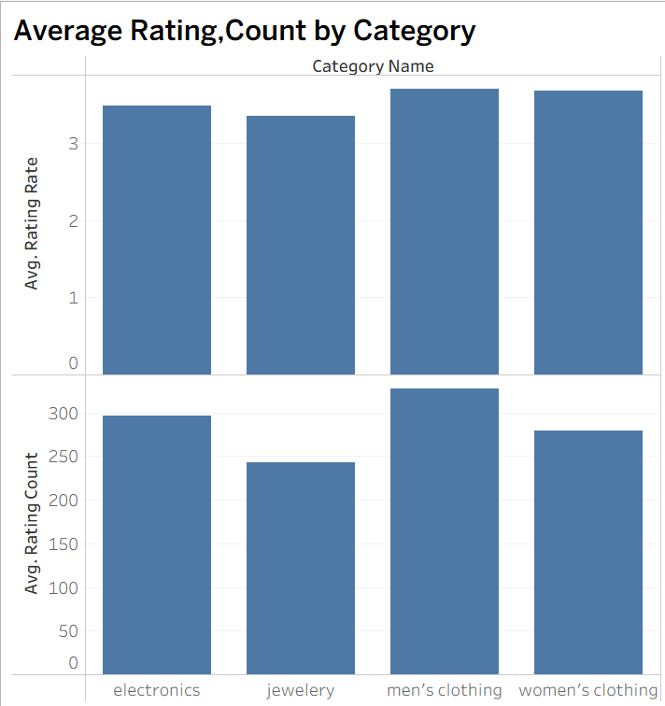

* **Men’s clothing** and **women’s clothing** achieve the **highest average ratings (~3.7–3.8)**, slightly outperforming electronics and jewelry.
* **Men’s clothing** also receives the **largest number of ratings (~325)**, indicating both strong engagement and high satisfaction.
* **Electronics** follows with a solid count (~295) and above-average rating (~3.5).
* **Jewelry** shows the **lowest rating count (~240)** and slightly lower average score (~3.4), suggesting weaker customer engagement.

**Insight:** Apparel categories perform best in both popularity and satisfaction, while jewelry appears to lag in both dimensions. This indicates an opportunity for deeper product or service improvements in jewelry to drive engagement and ratings.

2. Revenue Generated from each category

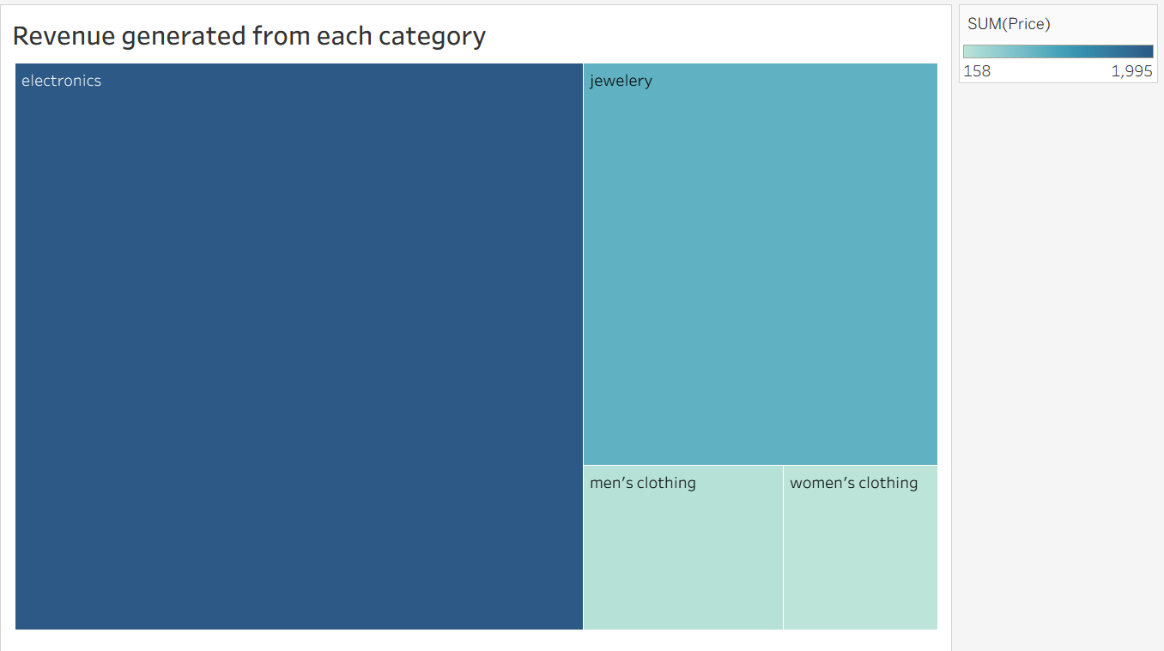

Electronics generated the highest revenue, followed by jewelry, men’s clothing, and women’s clothing.

Insight : Despite having fewer ratings and purchase counts, electronics and jewelry contributed significantly more revenue, indicating that these categories consist of higher-priced items. This suggests that product value, rather than sales volume, is driving revenue in these segments.

3.